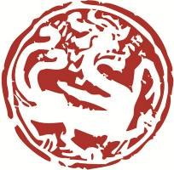
7th Museum Professional Exchange Programme

Organized by Art Museum, The Chinese University of Hong Kong,
Sponsored by Bei Shan Tang Foundation

Financial Aid Application Form

Name: |  | Email:
Institution: |  | Position

Would your institution provide any subsidization for your participation in this programme?

Yes |  | （please specify the amount: ） |  | No

Requested amount of financial aid from the organizer:

Please justify your application for financial aid of the Programme.

Would you withdraw from the Programme if your application for financial aid fails? Please explain.

Signature︰__________________________ Date︰ ____________________________

Notes to Applicants
- Completed financial aid application form, together with a stamped declaration of failure to provide full subsidy for your participation in the Programme signed by your institution’s Director should be sent to the Art Museum via email (museumworkshop@cuhk.edu.hk).
- The form and declaration, together with your application and recommendation forms for the programme must reach the Art Museum by 19th August, 2019 (Mon).
- All the applications will be passed to the Programme Committee for assessment and approval. No more than half of the programme fee shall be waived for successful applicants.
- Successful applicants are required to make their payment within ten working days upon notification. Failure to do so shall be seen as giving up their place to the applicants in the waiting list.

