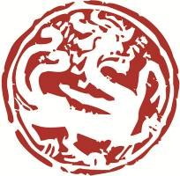
Museum Professional Exchange Programme

Organized by Art Museum, The Chinese University of Hong Kong,
Sponsored by Bei Shan Tang Foundation

Recommendation Form

Part I (To be filled by the applicant)

Applicant︰ |  | Institution︰

Part II (To be filled by the referee)

Name ︰ |  | Position︰
Institution︰
Address︰
Tel.︰ |  | Email︰

- How long have you known the applicant?

- In what context did you gain understanding of the applicant’s academic and/or professional qualification?

- Please rate the applicant on the items below:

 | Excellent | Good | Satisfactory | Below Average | N/A
Attitude at Work
Professional Knowledge
Adaptability and Perseverance
Decision-making
Communication Skills
Collaboration Skills
Others (please specify)︰
_______________

- Please comment on the applicant's suitability for this programme:

- Will you recommend the applicant for this programme?

 | Strongly Recommended |  | Moderately Recommended
 | Recommended |  | Not Recommended

I wish to receive promotional materials of the Programme in the future.
I wish to subscribe to the e-newsletter of Art Museum, CUHK.

Signature︰______________________________ Date︰___________________________________

Notes to Referees:
Please note that this recommendation form should be delivered to the Art Museum by email via museumworkshop@cuhk.edu.hk on or before 31st July, 2018. (Email Subject: Museum Professional Exchange Programme 2019)

